2018 年德國各地區指定抵達時間表




Arrival dates
If not stated different, we expect your arrival in Summer 2018 at the following dates. Do not book at different flight dates unless approved by your Host Club/Host Family:

If hosted by...
Rotary District 1800
01nd to 06th August 2018
Rotary District 1810 (State Rheinland Pfalz)
17st to 25st August 2018
Rotary District 1820
27th July to 01th August 2018
Rotary District 1830
0^{1rd} to 06th September 2018
Rotary District 1841
10th to 16th August 2018
Rotary District 1842
10th to 16th August 2018
Rotary District 1850
01st to 06th August 2018
Rotary District 1860
27st July to 01st August 2018
Rotary District 1870
17th to 25th August 2018
Rotary District 1880 (Free State Saxonia)
01st to 0^{6th} August 2018
Rotary District 1880 (Free State Bavaria)
01st to 06th September 2018
Rotary District 1890
10th to 16th August 2018
Rotary District 1900
17th to 25th August 2018
Rotary District 1930
01st to 06th September 2018
Rotary District 1940
10th to 16th August 2018
Rotary District 1950 (Free State Bavaria)
01^{sth} to 06th September 2018
Rotary District 1950 (Free State Thuringa)
01^{sth} to 06th August 2018
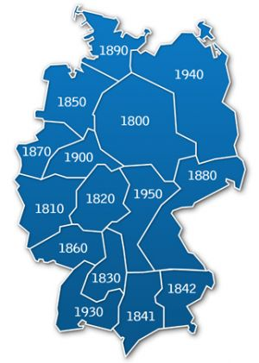
Inbound Insurances
All Inbound Students coming to Germany have to buy a German Insurance before they leave home to travel to Germany. The insurance is underwritten by the HanseMerkur Versicherungs AG. The insurance covers the risks health, liability and accident.
Long Term Exchange students buy an insurance cover for 12 months;
Short Term Exchange students buy an insurance cover for the length of their stay –including the days of travel- from 1 to 90 days.
All students must buy a Travel Health Insurance (Long Term: 385 Euro per 12 months; Short Term: 0,95 Euro per day) plus a Travel Accident, Liability and Emergency Insurance (Long Term: 50 Euro per 12 months; Short Term: 0,20 Euro per day). Both types of insurance are compulsory.
The insurance meets the RI requirements. In accordance with the Rotary exchange rules all students have to have a Health and Liability Insurance. The German Rotary District Governors have decided that all Inbound students coming to Germany have to be insured with the German Insurance Company Hanse-Merkur Versicherungs AG.
The insurance has to be bought online before the student leaves home to travel to Germany; the Guarantee Form only can be returned after the student has bought insurance. The insurance policy is a contract between the parents/legal guardians of the exchange student and the HanseMerkur Versicherungs AG. Please read the insurance conditions carefully; include the travel days from the home country to Germany (departure day) and trip home (arrival day). The insurance covers the trip to/from Germany (house to house).
Please read the terms of HanseMerkur carefully.

How to enroll online for your insurance cover?
Please click on the number of your Host District below and follow the online instruction of the insurance program.
District 1800
District 1810
District 1820
District 1830
District 1841
District 1842
District 1850
District 1860
District 1870
District 1880
District 1890
District 1900
District 1930
District 1940
District 1950

